Ashley Bailey  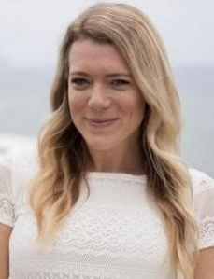 | Ashley is an ocean lover and really enjoys surfing, cooking Italian food, dining, traveling internationally, sailing to new destinations, entertaining guests, and spending time with her ‘Ohana. She is half Sicilian and half Irish-American. She graduated with a business marketing degree from university of Massachusetts Dartmouth. When she is not matchmaking people with property, she is an avid sailor and races every Friday night and in multiple regattas a year out of the Hawaii & Waikiki Yacht Club. Alongside of real estate, she can assist with delivering yachts to Hawaii or finding a yacht to purchase. She is able to assist her clients in relocating worldwide with her partnership with Leading Real Estate Companies of the World. She loves traveling and connecting the people from Hawai’i to Italy and vice versa.
Esmeralda Carini, Ph.D.  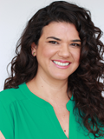 | Esmeralda is a proud Sicilian-Columbian American that was lucky enough to grow up in Hawaii. She is currently the District Literacy Content Specialist for Kailua Kalaheo Complex Area, Windward District and holds a Ph.D. in Education Literacy Leadership from the University of Hawaii, Manoa. Esmeralda has lived and worked in Florence and Rome Italy for many years and plans to return one day. Her interests include spending time in the ocean, cooking, and attending cultural events.
Diane DeSantis  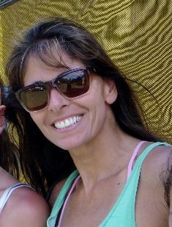 | Diane has multiple degrees in accounting, business and psychology, and brings over 25 years of bookkeeping and business experience. She also spent 25 years in high-level competitive indoor and outdoor doubles volleyball before switching to competitive tennis 10 years ago. Having moved from the Boston/NH 6 years ago, Diane, her husband Peter, and daughters Katy and Sara love Hawaii! Now that both daughters are off to colleges in NY (one is currently studying in Milano!), Diane hopes to use her empty-nester time to help Friends of Italy reach their 2019-2021 goals. She will also spend a month in Italy this May/June to reconnect with her parents and grandparents’ heritages, and is very grateful for all the wonderful members she has met in the Italian classes and at Friends of Italy events.
Genevieve Devine  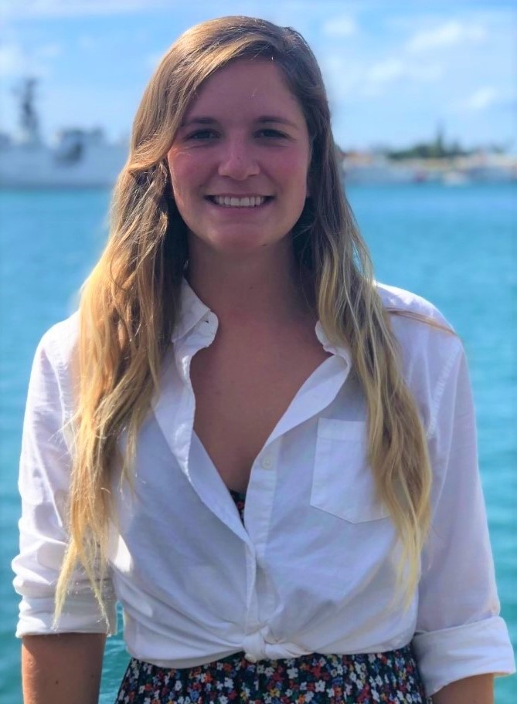 | Genevieve graduated from Massachusetts Maritime Academy in 2017 with a degree in Marine Science. After volunteering for two years of national service with AmeriCorps, she now works with the Hawaii State DLNR in the Division of Aquatic Resources. When she's not working to preserve Hawaii's beautiful and diverse ocean ecosystem, Genevieve loves to spend time in or on the ocean, sailing, snorkeling or SCUBA. She also has her Yoga Teacher Certification (YTT-200) and enjoys being outdoors, hiking and indulging in Italian cuisine. She dreams of one day going to Italy, to visit where her great grandparents were from, and is hoping to learn the language before traveling.
Maya Hoover, D.M. | Maya Hoover is a professional classical singer (mezzo-soprano) who has appeared in recital, concert, and opera throughout Europe, Central and South America, China, and the United States. She holds degrees from Indiana University (DM); Westminster Choir College (MM); and Binghamton University (BM), where she also minored in Italian language and literature. She studied in Florence at La Scuola Leonardo da Vinci, and has had the pleasure of spending several summers in Italy singing the great works of Puccini and Verdi. She is a roster artist with Wade Artist Management in New York, and she serves as Professor of Music and voice area head at the University of Hawai`i at Mānoa.
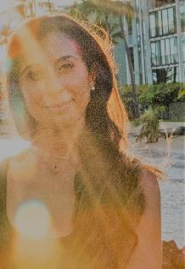  Chiara Logli, Ph.D. | Originally from Bologna (Italy), Chiara is the Institutional Assessment Specialist at the Honolulu Community College. She holds a Ph.D. in International and Cross-Cultural Education from the University of Hawaii at Manoa, with fellowships from the East-West Center, Rotary International, and the USA Foreign Language and Area Studies. Previously she worked for the University of California Berkeley and Santa Barbara as well as a consultant for USAID, CAST/International Baccalaureate Schools, and Asia Pacific Higher Education Research Partnership. She taught Italian language and culture at the Italian Consulate’s Institute in San Francisco and the Dante Alighieri Society in Santa Cruz. She dances hula with Halau Kaulakahi and loves the ocean, especially surfing and freediving.
Alison Mehrman  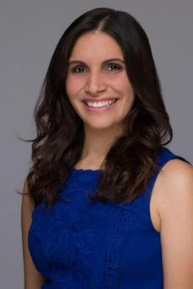 | A public relations professional and writer, Alison is currently the Community Engagement Manager at Make-A-Wish® Hawaii, a top nonprofit in the state, where she oversees all communications and builds relationships with the local community. She earned her Master of Science in public relations from Boston University’s College of Communication. She also holds a Bachelor of Arts in English and Psychology from Merrimack College, where she graduated as the first-ranking student in humanities and was the college’s first-ever featured baton twirler. Having worked as a writing instructor and communications professional for years, she enjoys storytelling above all else. Her free time reflects her love for language as well, as she learns Italian and dreams of one day publishing a novel. She also enjoys Italian cooking, painting, and exploring the Hawaiian Islands.
David Morihara | David retired from a career in legislation, higher education, and business. He served for ten years in the legislature as the State Representative for Upcountry Maui in the Hawaii State House of Representatives. In that capacity, he served as Chairman of the Higher Education Committee and Chairman for the Agriculture Committee to promote Hawaii products—he founded the “Made in Hawaii Festival” at the Blaisdell. He also worked for the Office of the Governor and as the Director of Government Relations at the University of Hawaii to developed legislative packages. He has served in numerous boards of directors, including Maui Chamber of Commerce, Hawaii 4-H Foundation, College of Tropical Agriculture, and Valley Isle Road Runners. He loves hiking, gardening, travelling, Italian food, and Roman history.
Marco Schlesser  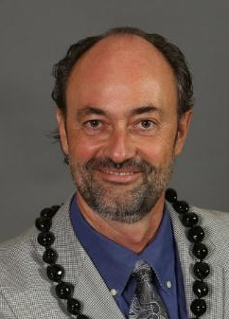 | Marco was born in the Grand Duchy of Luxembourg, as second generation of Italian immigrants. He studied law, accounting, economics and management. In Luxembourg being a banking center, Marco initially joined the Industrial Bank of Japan’s Luxembourg office as vice-president of the loan, capital market, and research department and as advisor to the managing director on issues relating to Luxembourg and the European Union. Since 2005, Marco has been the Relationship Manager at Heartland, where he consults with businesses for payments and payroll/HR solutions in Hawai’i and across the US. As a Realtor Associate with the local brokerage Engel & Voelkers, Marco's knowledge and experience for connecting people is only matched by his love for real estate. He is fluent in English, French, German, Luxembourgish with some very basic knowledge of Japanese. He is an active in Rotary since 1999 and current President of the Rotary Club of Honolulu Sunset. In his free time, he occasionally plays Bocce and Tennis, loves to cook and entertain, and enjoys fine wine and food.

